**Abdulla Isa Ayyad**

**E-mail:stgas2@outlook.com**

**Mob: +97366642333 / +97336555303**

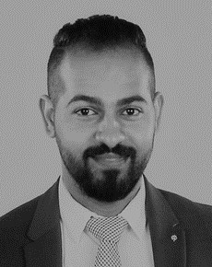

**Personal Details:**

Nationality: Bahraini

Date of Birth: 03/MAY/1991

Address: AL-Hajar–Bahrain

Marital Status: Married

Languages: Arabic & English

**Objective:**

I am looking forward to having a good position in a well reputed organization that experience can be shared & enriched. Looking for an opportunity where I can improve the quality and professional skills through continuous learning to achieve the objective of becoming an excellent professional and no doubt to benefit the organization with my expertise.

**Experience:**

1. Edarati as Admin Manager (From Jan-2018 To Present)
2. Universal Electro Engineering UNEECO as Admin Assistant & Debt Collector (From 2016 to 2018)
3. Aramex as Warehouse Assistant & Clearance (From 2012 To 2013)

**Education:**

Secondary School Certificate from Ahmed AL-Omran Secondary School2006-2009

**Additional Courses:**

1-Warehouse & Logistic Management Course

2-Retail Course

3-Health & Safety Course

**Computer skills:**

Operating Systems: Mac Os, Windows

MS Office (Word, Excel, PowerPoint,)

**Skills:**

1-Very Reliable and Self-Motivated

2-Can Work Under Pressure

3-Hard Working

4-Ability to Work in Group, team player